## Change the Survey Language in ODK

If a survey has had multiple languages encoded you can switch between them when filling out the form. After loading the form, open settings, select Change Language, and then select the desired language.

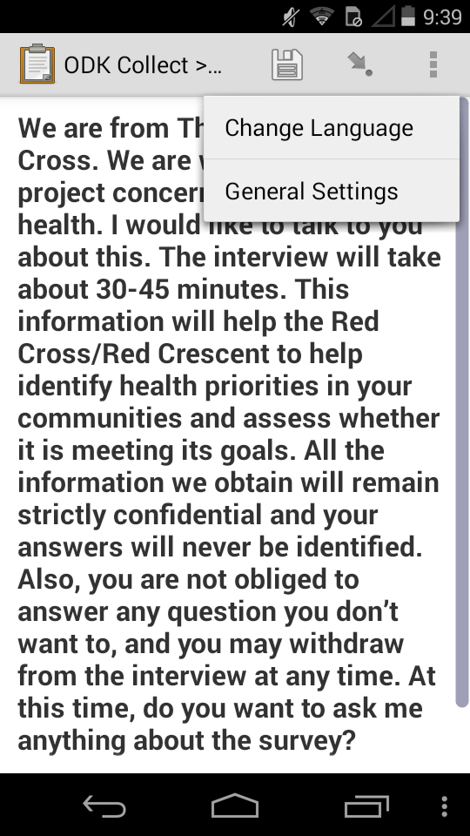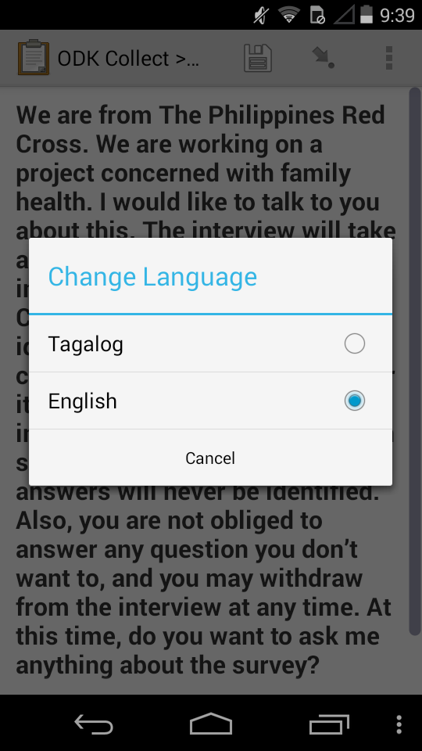

The language loaded by default can be set in the XLSform. Add a sheet named “settings” and add a column headed “default_language” with the value of the desired default language from your survey and choices sheets. Note: Spelling and capitalization needs to match.

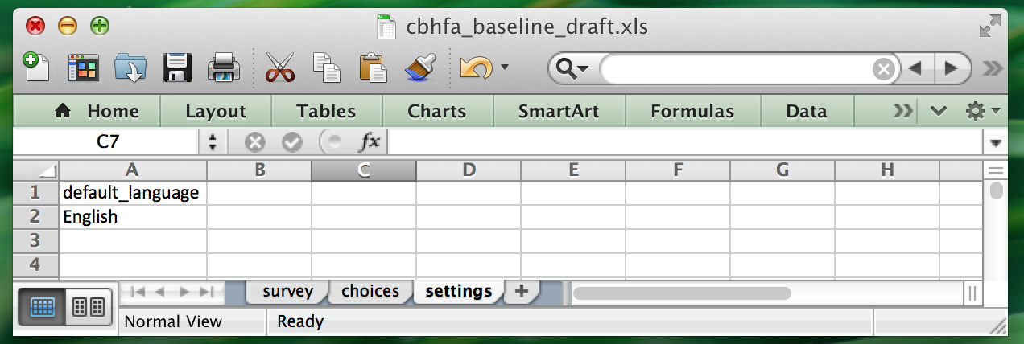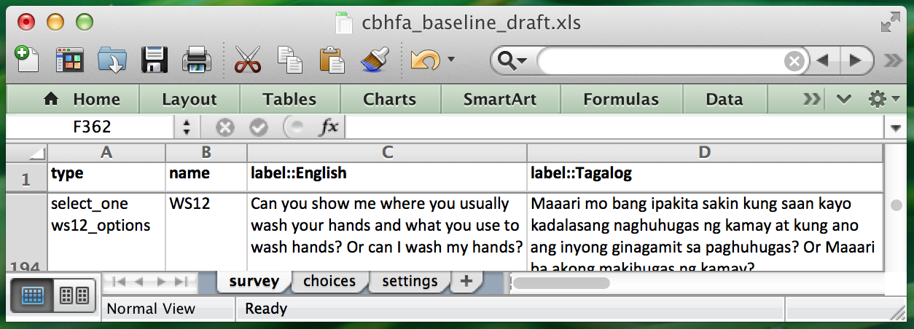

**For more on multiple language support visit** [**http://xlsform.org/#language**](http://xlsform.org/#language)